User Testing
Clone the repo from github.com/nsp4746/DASE & follow the instructions found in the read me
From the GUI, select a company, a level of technical difficulty, and the amount of adversary reactions (i.e., 3 represents the adversary will respond three times to your actions)

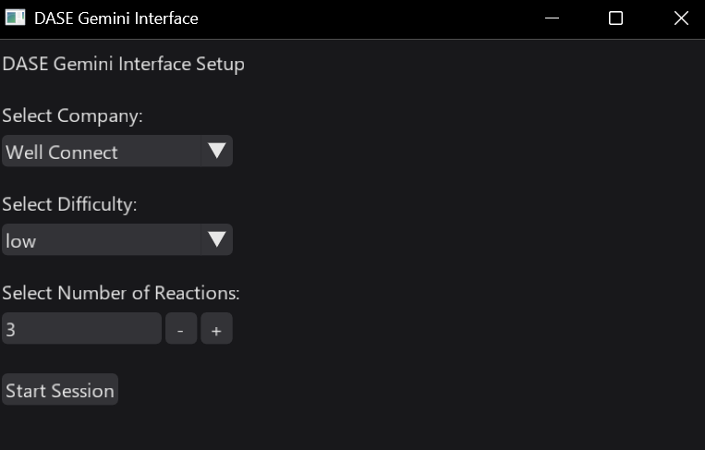
From here feel free to prompt the LLM for more information about the company, the key staff, the tech stack, etc.
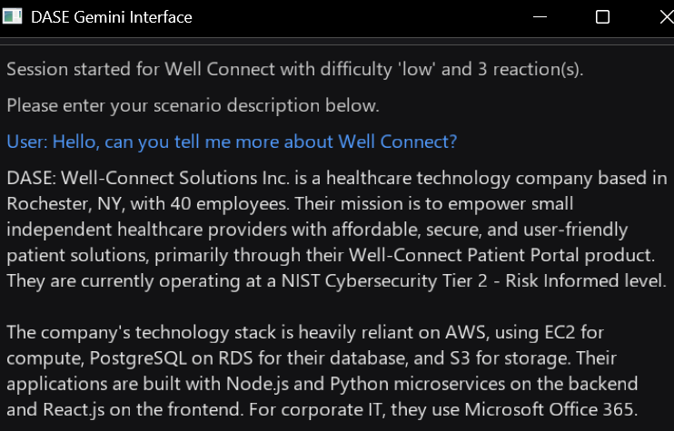
Once you are done with using the program, please answer the following questions.

System Usability & Interface
How intuitive is the interface?
Answer
Did you understand how to select a company and scenario without instruction or feel that you would’ve been able to with the steps on Pages 1&2
Answer
Did the system provide enough feedback (loading indicators, clear responses, etc.)?
Answer
Rate your satisfaction with the interface 1-5, with 1 being very low, and 5 being very high. Provide reasonings
Answer
What is one thing you would change about the interface?
Answer

LLM Output Evaluation
Were the responses relevant to the selected company scenario?
Answer
Did the AI use company specific details (tech-stack/vulnerabilies)?
Answer
Were the generated outputs easy to read and understand?
Answer
Did is structure responses logically?
Answer
Did the adversary simulation feel realistically and technically plausible?
Answer
Were any details inconsistent or incorrect?
Answer
Did the tone and style remain across different scenarios/sessions?
Answer
Were similar prompts producing similarly detailed results?
Answer
Did the system evert generate unsanfe or unethical outputs? (e.g. exploit code, step-by-step attack instructions)
Answer
At the end, did it include mitigation or defensive advice?
Answer

Scenario Coverage and Dynamics
Did you test multiple companies? Were the differences noticeable?
Answer
Did the AI tailor its responses based on the companies sector and NIST tier?
Answer
For each scenario type did the output include the key elements you would expect?
Answer
Was it clear how to modify the prompt or company context?
Answer
Would you prefer more customization (e.g. choose attack phase, output format)?
Answer

Performance and Reliability
Was the AI’s response time reasonable?
Answer
Did you encounter any errors?
Answer
Did the GUI crash, freeze, or misbehave?
Answer
If you ran the same query twice, were results consistent?
Answer

Quantitative Section
The GUI was intuitive to use (please mark an X)
1 (Strongly Disagree) | 2 | 3 | 4 | 5 (Strongly Agree)

The AI output was relevant to the company
1 (Strongly Disagree) | 2 | 3 | 4 | 5 (Strongly Agree)

The adversary simulation felt realistic
1 (Strongly Disagree) | 2 | 3 | 4 | 5 (Strongly Agree)

The AI maintained ethical and safe responses
1 (Strongly Disagree) | 2 | 3 | 4 | 5 (Strongly Agree)

I would use this system again for cyber trainings
1 (Strongly Disagree) | 2 | 3 | 4 | 5 (Strongly Agree)

Open-ended / Qualitative Feedback
What did you find most effective about this tool?
Answer
What limitations or issues did you notice?
Answer
How could the prompt or output format be improved?
Answer
Did the AI seem to understand the company context effectively?
Answer
What new features would make this system more valuable (e.g., scoring, custom prompts, scenario export)?
Answer

Example Tasks
Select AeroPay Financial Services and run a “Reconnaissance” simulation.
- Evaluate realism and technical plausibility.

Select MetroGrid Manufacturing and run a “Lateral Movement” simulation.
- Evaluate whether output adapts to OT/ICS context.

Query for specific company info (e.g., “Show MetroGrid’s technology stack”).
- Evaluate JSON-driven context retrieval.

